**Project Management Plan Template**

(Group-4)

**Project Management Plan**

**Ride Share Management System**

|  |  |
| --- | --- |
| **Name** | **ID** |
| Asif Sharif Akash | 20-42647-1 |
| Maharabur Rahman Apu | 20-42675-1 |
| Masud Pervez | 20-42656-1 |
| MD Shah Jalal | 20-43479-1 |

**27 August, 2023**

**Table of Contents**

1. INTRODUCTION 3

2. PROJECT MANAGEMENT APPROACH 3

3. JUSTIFICATION 5

4. OBJECTIVES AND PROJECT SCOPES 5

5. OVERVIEW OF THE PROJECT 6

6. STAKEHOLDERS ANALYSIS 7

**6.1** **PRIMARY STAKEHOLDER:** 7

**6.2** **SECONDARY STAKEHOLDER** 8

7. MILESTONE LIST 9

8. PROCESS MODEL TO BE FOLLOWED 9

9. WORK BREAKDOWN STRUCTURE 11

10. ESTIMATION 11

11. RESOURCE REQUIREMENTS 12

**11.1** **SOFTWARE REQUIREMENTS** 12

**11.2** **HARDWARE REQUIREMENTS** 12

**11.3** **HUMAN RESOURCE REQUIREMENTS** 13

12. PROJECT SCHEDULE 13

13. DELIVERY PLAN 14

14. RISK ANALYSIS 15

15. QUALITY CONTROL PLAN 16

16. BUDGET 17

**CONSTRUCTIVE COST MODEL** 17

**BUDGETING** 17

17. CONCLUSION 18

# INTRODUCTION

The "Ride Sharing Management System" software requirements are listed in this document. Providing a platform that enables people to share rides with others who are traveling in the same direction is the goal of a ride-sharing with another passenger project. The project intends to lower transportation costs, ease traffic congestion, and lessen the carbon imprint of transportation by linking drivers and passengers who are traveling in the same direction or along the same route. Additionally, ride-sharing with another traveler has social and environmental advantages because it fosters new relationships, helps people lessen their individual environmental impact, and advances a more sustainable and effective transportation system. The initiative aims to provide a practical, cost-effective, and environmentally friendly transportation option that benefits both passengers and drivers by making it simpler for people to share trips. The product explains every component of the system that a passenger uses to board a vehicle and, if at all possible, share it with another passenger.

Anyone who has to go from one location to another and is interested in sharing a journey with others who are traveling in the same direction would be the target audience for a ride-sharing with another passenger project. This might apply to commuters, students, tourists, and anybody else searching for a cost-effective and practical mode of transportation.

# PROJECT MANAGEMENT APPROACH

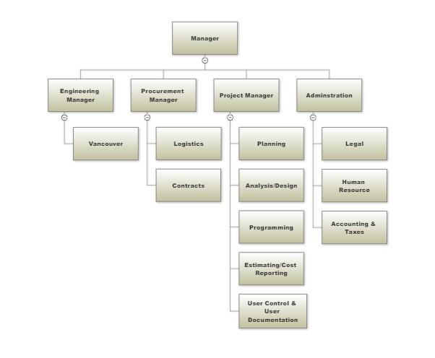

**Figure: Organizational Hierarchy**

The figure suggests the organizational hierarchy of our project where there are four departments for Manager under which are the Engineering Manager, Procurement Manager, Project Manager and Administration.

* **Engineering Manager:** An engineering manager's responsibilities also include managing finances, coordinating one or more engineering teams, and planning, developing, and managing projects. The number of engineering teams and managers who report to an engineering manager increases as he or she climbs the technical management ladder.
* **Procurement Manager:** A procurement manager oversees and supervises the acquisition of all the products and services that a business need. They are in charge of locating suitable suppliers, conducting vendor interviews, negotiating advantageous supplier agreements, and administering vendor and supplier contracts.
* **Project Manager:** The project manager plans and oversees the project, assigns any delegation and makes use of project assurance roles within predetermined reporting structures, and creates and updates project, stage, and exception plans as necessary.

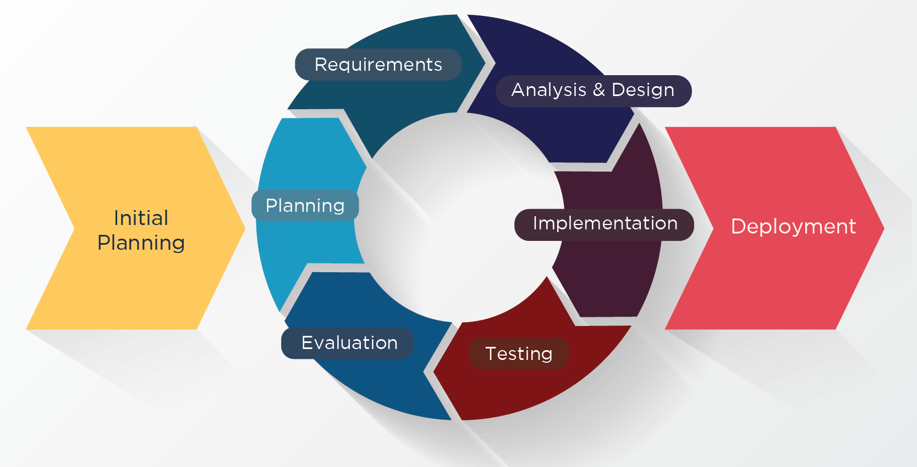

**Figure: Project Management Approach**

* **Administration:** An administrator is essential to the efficient operation of a firm and provides office support to either an individual or a team. They might be in charge of answering phones, welcoming and guiding guests, word processing, making spreadsheets and presentations, and filing.

**PROJECT TITLE:**

The title of the project is Ride Share Management System.

# JUSTIFICATION

The benefit of this endeavor is that a single traveler can look for individuals to share a ride with. The gender of their drivers can be chosen by a traveler or passenger. The ratings of drivers may be used to select them. The administrator keeps an eye on car and driver licensing. A traveler can define their destination and invite other people to join them on the trip. The number of passengers will determine whether or not the tourists can choose their own vehicles or modes of transportation. The price of the trip can be divided between the travelers, who will each make their own payments. There are cash and credit card payment alternatives. The choice is up to the driver whether to accept or reject the ride request. If a driver declines a ride in any way, the driver may mention the request to other drivers. A passenger or tourist may complain about the driver and rank the driver accordingly.

# OBJECTIVES AND PROJECT SCOPES

**Objective:** The objective is to develop a ride-sharing system.

**Sub-objectives:**

* Create a log in system for the users
* To develop a system for the ride management
* To establish connection for the users
* To develop passenger and driver log
* To implement a GPS location system for the map and share location
* To develop a payment and accountable system
* Create a review and bonus reward section

**Scope:**

* **User Management:** Implement user-friendly registration and authentication processes for drivers and passengers using NID.
* **Driver Verification:** Allow administrators to verify driver credentials and manage driver information.
* **Ride Requests:** Enable passengers to submit ride requests, including gender preferences for drivers.
* **Real-Time Information:** Display available seats and real-time ride information.
* **Driver Dashboard:** Create an intuitive dashboard for drivers to manage requests and communicate.
* **Rating System:** Implement a user rating and feedback system for accountability.
* **Safety Features:** Integrate in-app communication, emergency assistance, and tracking.
* **Future Expansion:** Plan for updates and potential new services, supported by a strategic marketing approach.

# OVERVIEW OF THE PROJECT

A technology called ride sharing will enable single passengers to travel in groups with other people. Drivers and passengers will be the ones using the software the most in our system. Through their NID number, drivers and passengers can register and log in to the system. The administrator can log in and examine the driver's license, vehicle registration, and the availability of seats for the desired passengers. In order to customize the user experience, enhance safety, and give this application a competitive edge, it might enable riders to request the gender of the drivers. Therefore, creating this application can assist people/travelers in finding partners to share rides with at the lowest possible cost. There are many ride-sharing applications available right now. However, while requesting a ride, users are unable to specify the gender of their driver. Vehicle rides completely altered transportation with their rising popularity and public acceptability. This ride-request software has been a key contributor to the change to on-demand personal drivers, thus it will aid in growing the user base and optimizing market presence.

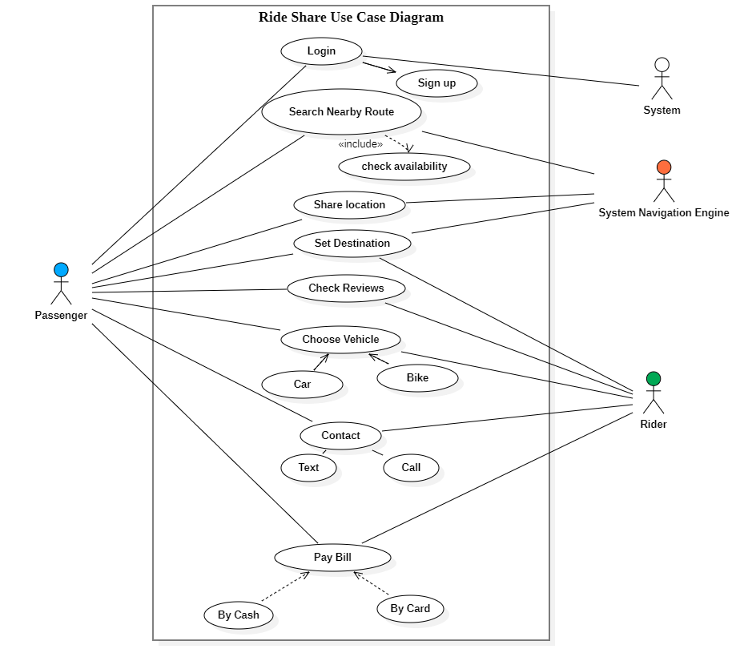

**Figure: Use-case diagram**

# STAKEHOLDERS ANALYSIS

## **PRIMARY STAKEHOLDER:**

1. **Drivers:**

* Interest: Seeking opportunities to earn income by offering rides.
* Influence: High, as they provide the core service of the platform.
* Concerns: Fair compensation, user ratings, convenience.

1. **Passengers:**

* Interest: Looking for affordable and convenient transportation options.
* Influence: High, as their demand drives the platform's success.
* Concerns: Safety, cost-effectiveness, user experience.

1. **Administrators:**

* Interest: Ensuring proper driver verification, user satisfaction, and efficient platform operation.
* Influence: Moderate, as they manage driver credentials and overall system functionality.
* Concerns: Driver compliance, user support, security.

1. **Application Developers:**

* Interest: Creating a user-friendly, reliable platform.
* Influence: High, as they build and maintain the technology.
* Concerns: App performance, updates, innovation.

1. **Society/Public:**

* Interest: Access to convenient, affordable transportation options.
* Influence: Indirect, as public opinion affects platform adoption.
* Concerns: Environmental impact, accessibility.

1. **Environmental Organizations:**

* Interest: Promoting eco-friendly transportation solutions.
* Influence: Low to moderate, based on their advocacy efforts.
* Concerns: Carbon footprint, sustainability.

## **SECONDARY STAKEHOLDER**

1. Government
2. Consultant
3. Business Analyst
4. HR Personnel

# MILESTONE LIST

|  |  |  |  |
| --- | --- | --- | --- |
| Milestone | Duration | Description | Date |
| Complete SRS | 8 weeks | The document specifies the functions and performance standards for the software. Additionally, it outlines the functionality the product must have in order to satisfy the demands of all stakeholders. | 6/09/22 |
| Design | 5 weeks | sufficient in detail so that anybody who already understands the problem might code the project without having to make any major decisions | 14/10/22 |
| Complete Coding | 7 weeks | converting a system's design into a computer language format | 1/12/22 |
| Complete Testing and Debugging | 1 month | Verifying that a software system or component satisfies its functional and non-functional criteria is called testing, whereas debugging is the process of finding and fixing problems with the software system. | 4/01/23 |
| Documents – User Guides and Installation | 4 weeks | An instruction manual that helps users of your software install, remove, and update your program | 14/02/23 |

# PROCESS MODEL TO BE FOLLOWED

The proper process model must be selected by a company in order to create successful software and get the intended result. We have chosen to use the Agile Process Model, specifically the Dynamic product Development Method (DSDM), for our "Ride Share Management System" software.

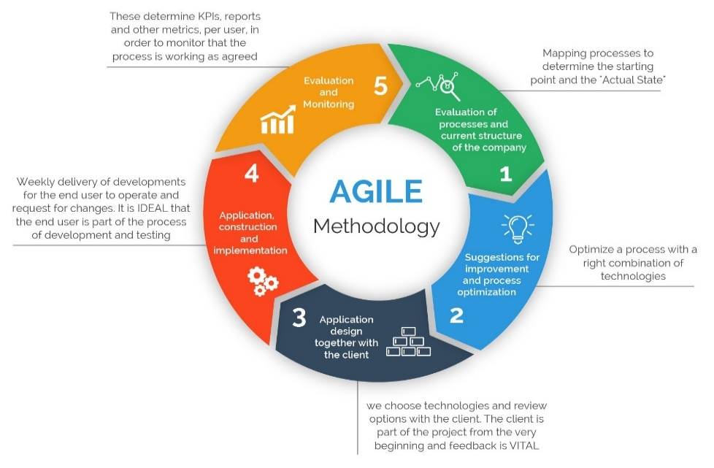

**Figure: Agile Model**

In order to focus on adaptability and customer happiness, the agile process model combines iterative and incremental procedures while providing functioning software solutions quickly. This approach divides the project into incremental, modest builds that are delivered over time.

The Agile Model is a good fit for our project because it is a medium-sized undertaking. A major consideration while selecting the Agile Process Model is adaptability because of the huge number of users that will be using the system and the potential for additional requirements. Our choice to embrace Agile was also influenced by our ability to interact directly with our clients. Furthermore, it is critical to finish our assignment as soon as feasible because it deals with a social issue.

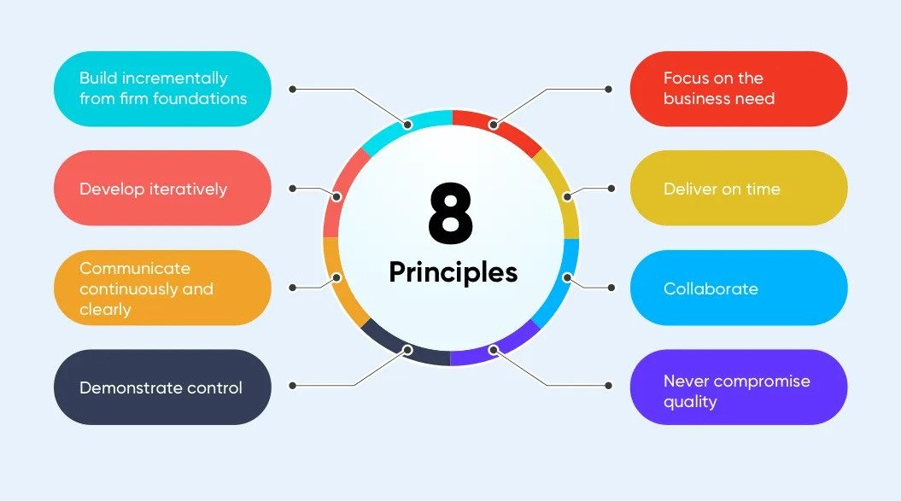

**Figure: DSDM 8 Principles**

The Dynamic Software Development Method (DSDM)'s rapid application development method, which offers an agile project distribution structure, is the main argument for picking it. Given that our users are always connected, this fits with the essential DSDM capabilities. For our project, the eight DSDM guiding principles are a perfect fit. We must, for instance, prioritize business requirements, produce on time, never cut corners on quality, use iterative development, and communicate honestly and frequently.

# WORK BREAKDOWN STRUCTURE

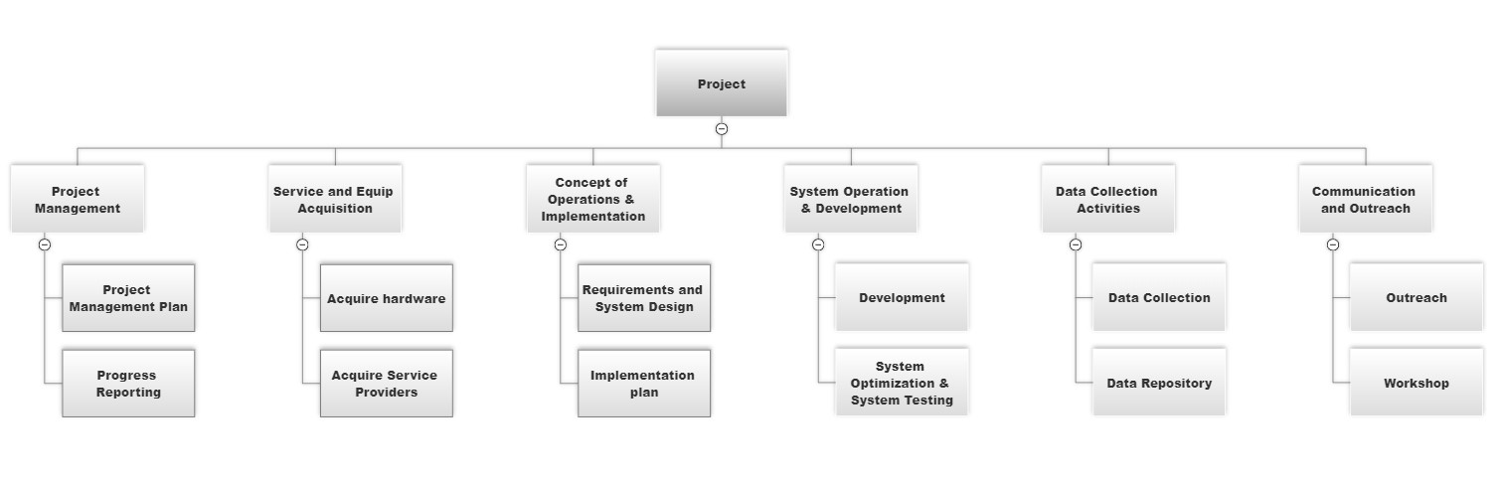

**Figure: Work Break Down Structure (WBS)**

# ESTIMATION

**Activity Table:**

|  |  |  |  |
| --- | --- | --- | --- |
| Activity Name | Activity Node | Duration(weeks) | Precedence |
| Requirement Analysis | A | 4 | - |
| Design | B | 2 | A |
| Development | C | 12 | A |
| Implementation | D | 4 | B |
| Testing | E | 4 | D |
| Training | F | 4 | E |
| Installation | G | 4 | F |
| Delivery | H | 1 | G |
| Support | I | 12 | H |

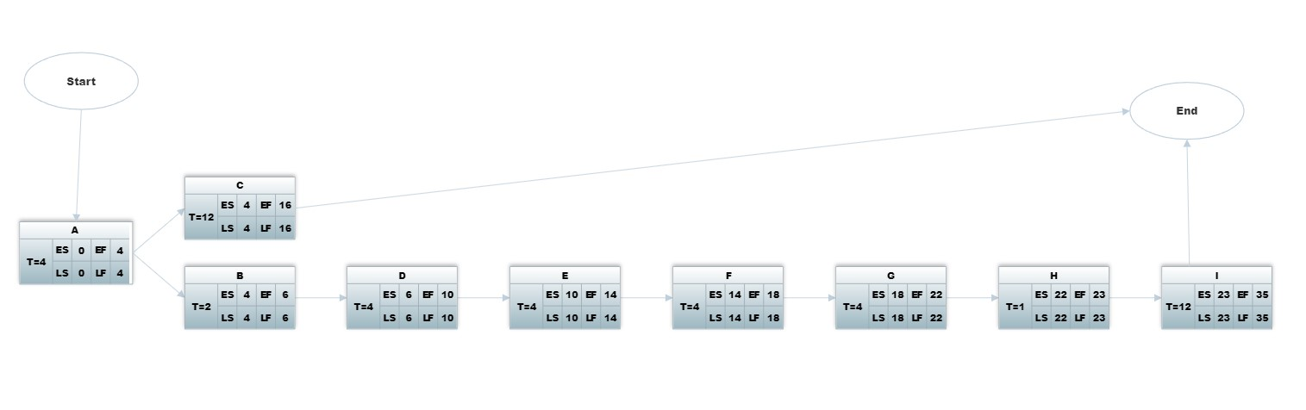

**Figure: Activity Diagram**

# RESOURCE REQUIREMENTS

## **SOFTWARE REQUIREMENTS**

* **Requirement gathering Tools:** The system developer needs JIRA tools to perform managing, gathering, documenting the requirements for this software.
* **Prototyping tool:** These tools help in creating quick mockups and prototypes of the software to get feedback from stakeholders. Examples of such tools include Balsamiq, Axure, and Sketch.
* **Project management Tools:** The system developer needs smartsheet, Microsoft project to managing the overall project, including scheduling, resource allocation etc.
* **Testing tools:** The system developer needs selenium tools in perform testing activities before delivering the final product.

## **HARDWARE REQUIREMENTS**

* Router
* Monitor
* Processor
* Cables
* Keyboard/Mouse
* Database Server
* LAN
* **Graphics and Display (GPU)**
* **Memory (RAM)**
* **I/O Devices**

## **HUMAN RESOURCE REQUIREMENTS**

* **Project Manager**: Responsible for overall project planning, coordination, and communication. They ensure that the project stays on track and manages risks effectively.
* **Business Analyst**: Works closely with stakeholders to gather and document project requirements, translating business needs into technical specifications.
* **Software Developers**: Responsible for writing code, implementing features, and ensuring the software functions as intended. The number of developers depends on the project's size and complexity.
* **Quality Assurance (QA) Engineers**: Test the software to identify bugs, issues, and ensure that it meets quality standards. They help maintain the software's reliability.
* **UI/UX Designers**: Create the user interface and experience design, ensuring the software is user-friendly and visually appealing.
* **Database Administrators (DBAs)**: If the project involves a database, DBAs manage database design, optimization, security, and maintenance.
* **DevOps Engineers**: Responsible for automating the deployment, scaling, and management of the software, ensuring smooth operations.
* **Technical Writers**: If the project requires documentation, technical writers create user manuals, guides, and other documentation.
* **Security Experts**: In projects dealing with sensitive data or security requirements, cybersecurity experts ensure that the software is developed with proper security measures in place.
* **Scrum Master / Agile Coach**: If following Agile methodologies, these roles facilitate the Agile process and ensure effective team collaboration.
* **Support and Maintenance Team**: After the project is launched, a team might be needed to provide ongoing support and maintenance, addressing issues and releasing updates.

# PROJECT SCHEDULE

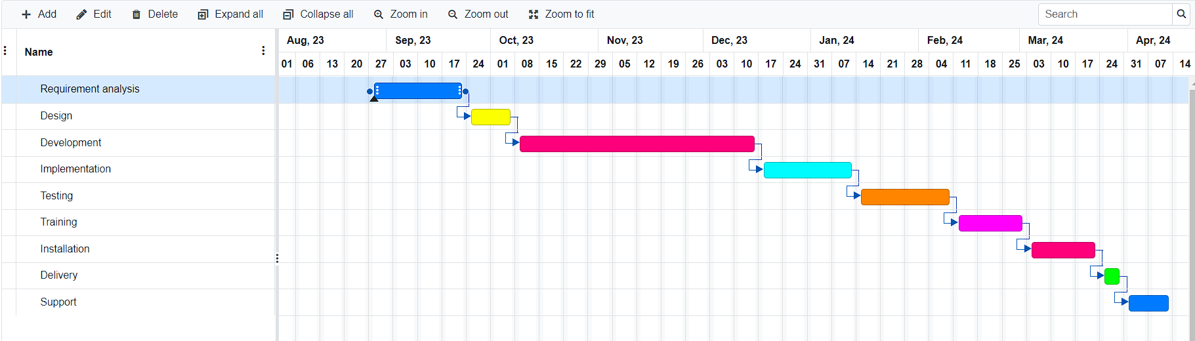

**Figure: Gantt Chart**

# DELIVERY PLAN

There are several process models that can be followed to build the Pathao ride share system. One such model is the Agile development model, which is an iterative and incremental approach to software development. The Agile development model is well-suited to building a complex system like the Pataho ride share management system, as it allows for continuous improvement and iteration based on user feedback. This model ensures that the system is built efficiently and effectively, and that it meets the needs of its users.

1. **Project Initiation:**

* Define the project's vision, goals, and scope.
* Identify stakeholders and their roles.
* Create the initial product backlog, capturing high-level requirements.

1. **Release Planning:**

* Identify the major features and functionalities required for the initial release.
* Prioritize items in the product backlog based on business value and complexity.
* Estimate effort for each item using techniques like story points or t-shirt sizing.
* Define the first iteration (sprint) length (e.g., 2 weeks).

1. **Iteration 1 - Sprint Planning:**

* Select items from the prioritized backlog to be included in the first iteration.
* Break down selected items into user stories with clear acceptance criteria.
* Define the tasks required to implement each user story.
* Estimate the effort for each task.
* Commit to delivering a potentially shippable product increment by the end of the sprint.

1. **Iteration 1 - Sprint Execution:**

* Daily stand-up meetings to discuss progress, challenges, and plans.
* Developers work on their tasks collaboratively.
* Testers create and execute test cases based on user stories.
* Designers work on UI/UX elements if needed.
* Regularly update the sprint backlog and task status.

1. **Iteration 1 - Sprint Review:**

* Demonstrate the completed user stories and features to stakeholders.
* Collect feedback and identify necessary changes or adjustments.
* Review what went well and what can be improved.

1. **Iteration 1 - Sprint Retrospective:**

* Reflect on the team's performance during the sprint.
* Identify areas for improvement in processes, communication, and collaboration.
* Make adjustments to the process based on retrospective findings.

1. **Iteration 2+ - Repeat:**

* Continuously repeat the sprint cycle for subsequent iterations.
* Regularly refine and reprioritize the product backlog.
* Incorporate feedback from stakeholders and end-users.
* Incrementally add new features and enhancements based on priority.

1. **Release and Beyond:**

* After several iterations, conduct thorough testing and quality assurance.
* Prepare for the official release of the product.
* Monitor the product's performance and gather real-world usage data.
* Plan future iterations based on user feedback and changing business needs.

Remember that Agile projects are highly adaptable, and the delivery plan may evolve over time as you gain more insights and information during each iteration. Flexibility and regular communication with stakeholders are key components of a successful Agile delivery plan.

# RISK ANALYSIS

Risk analysis is an important step in the development of any software system, including the Ride share system. The project may face different risks that could potentially impact its success. These risks include technical risks such as system bugs, performance issues, and delays in development, security risks such as unauthorized access and data breaches, resource risks such as a shortage of resources or loss of key personnel, regulatory risks such as non-compliance with healthcare and privacy regulations, adoption risks such as low user engagement, and infrastructure risks such as network failures and power outages. To mitigate these risks, the development team should take measures such as conducting thorough testing and research, implementing robust security protocols, establishing contingency plans, and maintaining regular communication with stakeholders.

|  |  |  |  |  |
| --- | --- | --- | --- | --- |
| **Risks** | **Category** | **Likelihood** | **Impact** | **Risk Exposure** |
| System bugs | TE | 3 | 3 | 9 |
| Unauthorized access | BU | 5 | 2 | 10 |
| Data breaches | BU | 4 | 1 | 4 |
| Shortage of resources | DE | 2 | 3 | 6 |
| Higher rate of user management | PS | 6 | 2 | 12 |
| Network Failures | TE | 2 | 1 | 2 |
| Lack of training tools | DE | 8 | 2 | 16 |
| Change in requirements by customers | PS | 8 | 2 | 16 |
| Improper maintenance | ST | 3 | 1 | 3 |

**Figure: Risk Table for Ride Share**

**N.B:** Impact Values

1. Catastrophic
2. Critical
3. Marginal
4. Negligible

**Risk Probability** = 80% (Most Likely)

# QUALITY CONTROL PLAN

Quality Control Plan (QCP) for this software project outlines the processes, activities, and methodologies that will be followed to ensure the quality of the software being developed. It is a structured approach to identify, monitor, and rectify issues throughout the software development lifecycle. The QCP helps to deliver a reliable, functional, and high-quality software product. Here are the key components typically included in a software project's Quality Control Plan:

* **Roles and Responsibilities**: Clearly define the roles and responsibilities of each team member involved in quality control activities. This includes roles such as Quality Assurance (QA) testers, developers, project managers, and stakeholders.
* **Testing Strategy**: Outline the testing approaches that will be used, such as unit testing, integration testing, system testing, user acceptance testing, and regression testing. Specify the tools, techniques, and environments to be used for testing.
* **Test Case Design**: Describe how test cases will be designed, documented, and organized. This involves outlining the process of deriving test cases from requirements, user stories, and design specifications.
* **Change Control**: Detail how changes to the software will be managed and controlled. Describe the process for documenting and assessing the impact of changes, and how they will be tested and validated before implementation.
* **Configuration Management**: Define how the software's configuration will be managed to ensure that changes are properly tracked and controlled. This includes version control, release management, and ensuring consistency across environments.
* **Metrics and Reporting**: Define the metrics that will be used to measure the quality of the software. This could include metrics related to defect density, test coverage, code complexity, and more. Outline how these metrics will be collected and reported.
* **Continuous Improvement**: Describe how the QCP will be reviewed and improved over time based on lessons learned from the project. This ensures that best practices are continually integrated into the process.

# BUDGET

## **CONSTRUCTIVE COST MODEL**

**Project type : Organic**

**Coefficient<effort factor> : 2.40 [P=1.05, T=0.38]**

**SLOC : 7700 Lines**

**Person Months : (2.40* 7.71.05) = 20.47**

**Dev. time, DM : (2.50* 20.470.38)=7.87=8Months=1408WH**

**Required People, ST : PM/DM = 20.47/7.87 = 2.60 = 3**

## **BUDGETING**

**Developer Salary in 8 months:**

**Per Developer salary per working hour = 550 Tk**

**Total Developer salary= 550*1408 = 774,400 Tk.**

**PM’s Salary in 8 months: 1,00,000 Tk.**

**Requirement Analysis:**

**Time-Needed: 1 month (22 working days= 176 working Hour)**

**Req Analysis Person’s Hourly wage =300 Tk.**

**Total Req Analysis expense = 300*176= 52,800 Tk.**

**Transportation Cost Estimation: 8,500 Tk.**

**Training & Hardware Expense Estimation: 92,000 Tk.**

**Rent Expense:**

**Room per Month = 10,500 Tk.**

**Total in 8 Months = 84,000 Tk.**

**Total Utilities in 8 Months (including miscellaneous):12,000 Tk.**

**Maintenance (Till 6 Months after Delivery):**

**Expense per Hour: 1000 Tk.**

**Total Estimated Time needed for Maintenance 60 Hours**

**Total Estimated Maintenance Expense = 60*1000 = 60,000 Tk.**

**Total Estimated Expense:**

**774,400 + 52,800 + 8,500 + 92,000 +84,000 + 12,000 + 60,000 + 1,00,000= 1,183,700 Tk.**

**Profit:**

**20% of Total Estimated Expense = 1,183,700 *20% = 236,740Tk.**

**Project Budget: 1,183,700 + 236,740 = 1,420,440 Tk.**

# CONCLUSION

There are opportunities to enhance the standard of current ride-sharing services and design effective new ones. Future research should concentrate on investigating the trip purpose of ride-sharing users (such as work, school, or shopping), looking into factors associated with ride-sharing before and after the service was implemented, and conducting cross-case studies between cities and nations on the same continent to compare findings. A very interesting yet difficult taking on that ought to consider into account regional and local differences is the formulation of ride-sharing policies. To assess the relationship that exists between users and ride-sharing for both current and potential users, more study is needed. Future research will focus on user factors associated with particular user activities and ride-sharing. While the most important system elements should be further examined to give tailored criteria that may be used into ride-sharing algorithms to maximize user-matching and experience, additional system aspects should be investigated to determine their impact on using ride-sharing services.